asses.masses – Preshow Information

This information is to help you decide if asses.masses is for you.
Content notes, including what happens in the show, are further in the document.

asses.masses is a custom-made videogame that has been designed to be played on stage by a live audience in a theatre. It tells the story of a herd of unemployed donkeys (otherwise known as asses) who leave their life on the farm to try and get their jobs back from the humans.

As an experience, asses.masses is a collaborative journey for the audience where the videogame is played from beginning to end in one sitting. It is a one player videogame where one person (at a time) uses the controller and the other audience members watch the story unfold, cheer the player on, offer suggestions, and help make decisions.

The Space
- The show is in Broadway’s Screen 1 (2nd Floor, accessible via stairs or lift)
- The audience will be in cinema seats that are facing a big screen. The player will be positioned in front of the audience, with minimal impact on visibility of the screen. Watching the game will look like this:
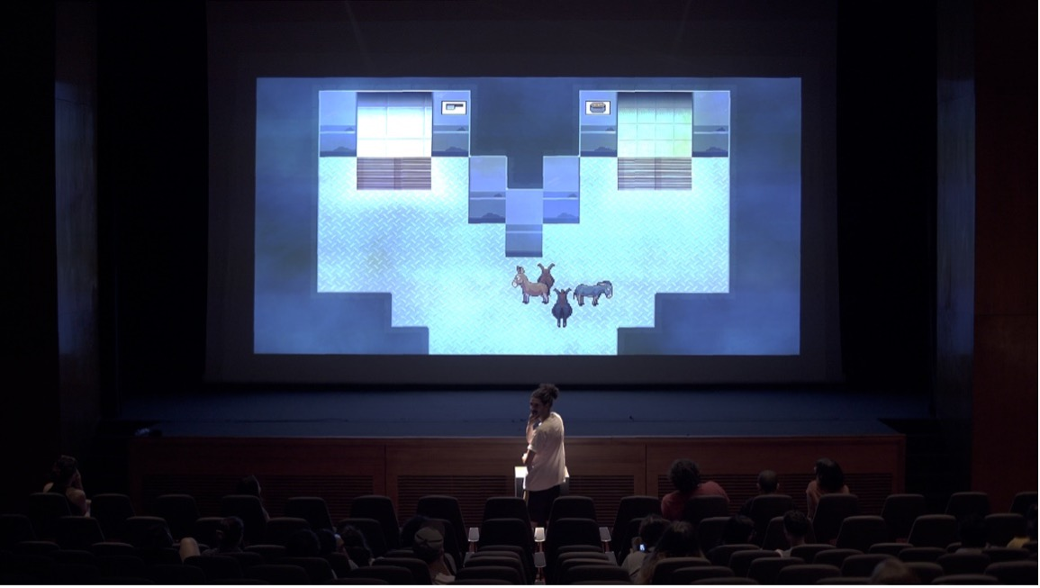
Lighting and Sound
- asses.masses is never completely dark except for one moment of blackout at the beginning of the show. Instead, lighting stays at approx. 25-40% to ensure visibility within the audience.
- Throughout the game there is loud music, sounds of screaming and flashing lights. Please see content notes for more detailed information.
Participation
You can decide throughout the experience if you would like to use the controller and play, or if you would like to watch others play the game. You can change your mind at any time.
Access Information
- Due to the design of the show, asses.masses is not a fully relaxed show; it is relaxed in spectatorship and has elements of a relaxed performance
- asses.masses is over 7 hours long and has 10 episodes
- There are intermissions every 2 episodes
- There are accessible toilets located via Screen 1 (to the right of the cinema screen) and on all levels of the building.
- There is a chill out space outside the performance space that is available anytime the building is open.
- The game is played using a PlayStation 4 (PS4) controller, which is provided. This requires holding the controller with two hands, the player pressing buttons, and, for some parts, a certain level of dexterity. A PS4 controller features two joysticks, four trigger buttons, a directional pad, an option button, a share button, plus triangle, cross/x, circle, and square buttons.
- asses.masses contains moments of game play that simulate the sensation of speed and movement in a 3D environment. This may cause dizziness or motion sickness for some audience members.
- asses.masses is projected on a large screen. Some spectators may find that the duration of looking at the screen is tiring on their eyes, or even able to provoke headaches.
- Please take a break if you are feeling dizzy or experiencing a headache.
- The story of asses.masses is told through visual text, which is delivered on screen in dialogue boxes that are controlled by the player, who presses the X button on the controller to advance to the next action/dialogue.
- There are no voice over or actors performing the text aloud, and you have to read it for yourself.

Content Notes
asses.masses has flashing lights, audience participation, violence, crude language, simulated donkey sex, simulated human sex, and references to drug use, suicide, and police brutality.

We recommend the show for audience members ages 15 and up. Under 18s must be accompanied by an adult.

Episode 1: The Protest
During this episode there are loud sounds of screams from the Humans in the Village. They are exaggerated and (sometimes) funny but also may be disturbing. When Trusty falls down the well, loud music plays and there is a video sequence containing an extended scene of flashing black text on a white background. The game transitions from a 2D pixel art world into a 3D world. During the Welcome Ritual loud rhythmic music plays.
Episode 2: The Fire
As Hard Ass looks for Humans there is the sound of loud screaming.
Intermission
Episode 3: The Mine
There is loud rock music of various genres that plays during the game of Rocks.
Episode 4: The Path
Racing games played in the Astral Plane contain disorienting visuals that could cause motion sickness. Mating games contain loud rhythm music. Depending on player choices, there is a concert featuring loud DJ music.
Intermission
Episode 5: The Zoo and the Circus
Episode 6: The Dream
The beginning of this episode begins with very loud noises (indistinct crashing and fighting sounds) while the screen is dark.
Intermission
Episode 7: The Factory
The Factory episode contains many moments of suspense and
strategy where the game play is accompanied by loud music, gunshots, and sudden banging noises. The various levels in this episode are skill-testing and may need to be played multiple times to complete. Audience members often yell out and cheer loudly. Loud music and sound effects play during this battle.

Episode 8: The Sanctum
The opening of this episode involves navigating a path in a 3D environment. This may cause some audience members to experience disorientation or feelings of motion sickness. There are loud sounds of hoofbeats whenever the Ass walks. In this sequence, as the cube appears, there is very loud music and sound effects.

Intermission
Episode 9: The Machines
There is a mini game sequence at the beginning of this episode that contains 3D movements and bright flashing lights.
Episode 10: The Riot
Loud music, donkeys braying, and sound effects play during the fight scenes that begin this episode. Once inside the Parliament building, there is a sequence with loud pulsing music. There is a loud moment of gunshot. Multiple gunshots and flashing lights on the screen.
Epilogue:
White screen is bright and black words are written in cursive script.

You can read further access information in asses.masses Access Guide: asses.masses_AccessGuide - Google Docs

